**Preliminary Variable Speed Advisory (VSA) Sign Location Consideration Field Test on EB SR78**

PATH Project Team Updated on 5/10/17

1. **Definitions:**

**VSA Sign:** Variable Speed Advisory Sign

**CMS (Changeable Message Sign)**: traditional Changeable Message Sign on the trailer

**Congestion Effected Range**: for freeway corridor traffic, when bottleneck congestion is activated, the maximum traffic back propagation range of the shockwave to the upstream of the bottleneck is called *Congestion Effected Range*.

1. **Control Range for VSA**

The control range should be mainly determined by traffic **Congestion Effected Range** for a freeway corridor. According to the Google Map traffic information in Fig.1 and a representative PeMS speed contour (Wed. Sept. 7, 2016) in Fig.2, the traffic congestion effected range for PM peak traffic is identified as the following location: EB SR78 from Civic Center Drive in the City of Vista (PM6.886) to I-15 interchange (PM T17.681).

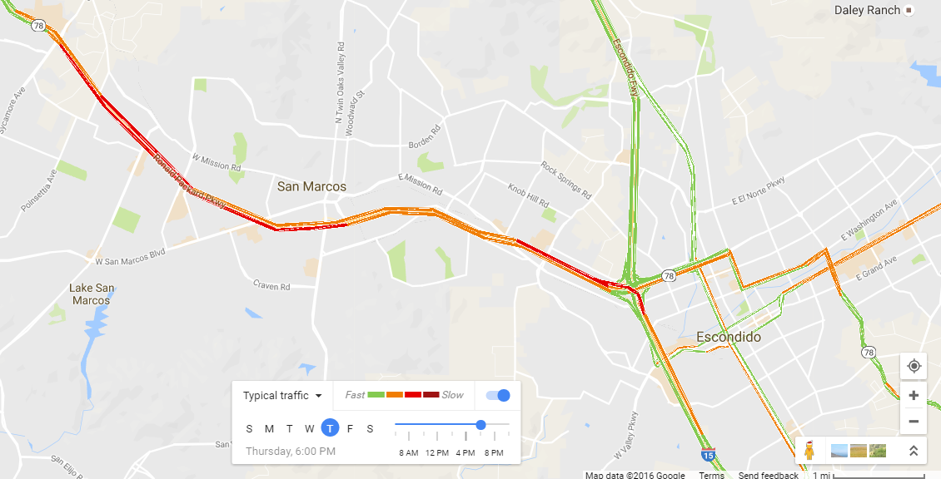

**Fig. 1:** EB SR78 PM Peak Congestion Effected Range: between Civic Center Drive in the City of Vista and I-15 Interchange



**Fig. 2**: EB SR78 PM Peak Congestion Effected Range from Civic Center Dr. in the city of Vista (PM6.886) to I-15 interchange (PM T17.681)

1. **Expected/Proposed Date of the VSA Field Test**

The proposed date of the VSA field test will be held between September and November 2017, for a period of 60 days. The VSA signs will be active during the PM peak period from 3:00 PM to 6:00 PM, Monday through Friday.

1. **Other Projects Executed at the same period on SR78**

The location of the construction project of the auxiliary lane on EB SR78 is from East of Twin Oaks Valley Rd. to West of Woodland Parkway (post mile 13.0-14.1) as shown in Fig. 3.

1. **Principles for the Determination of VSA Sign Locations**

The test site is on EB SR78 from Civic Center Dr. (PM 6.886) to w/o I-15 (PM T17.681). The total length of the test site is 10.8 miles. The location of one CMS and all seven VSA signs, along with the approximate distances between them, is shown in Fig 3. The location of the construction project of the auxiliary lane is also shown highlighted with a red line.

The principles of deploying VSA sign locations are as follows:

1. There should be reasonable distance between the VSA sign units to optimize driver response;
2. Density distribution, congestion location or on-ramp demand should be a factor;
3. VSA sign at a sharp curve of the road will help the driver to see for a longer distance;
4. The VSA sign unit should be located after off-ramp but before the immediate downstream on-ramp, which has medium to high demand in peak hours. The reasons for such selection are listed below:
5. the merging area of an on-ramp is likely to be a mainline traffic congestion area; the VSA can be used to regulate the demand before the merge area by adjusting the mainline traffic flow into the merging area (it is complementary to Ramp Metering); if the corresponding on-ramp has Ramp Metering, it will be used to regulate the demand from the on-ramp to the merging area as well, which is the case proposed by D11 ramp metering engineers;
6. If we put the VSA sign at or immediately after the on-ramp, it may cause distraction since the drivers from the on-ramp and the drivers in the first lane of the mainline need to concentrate on lane change maneuvers made from the on-ramp.

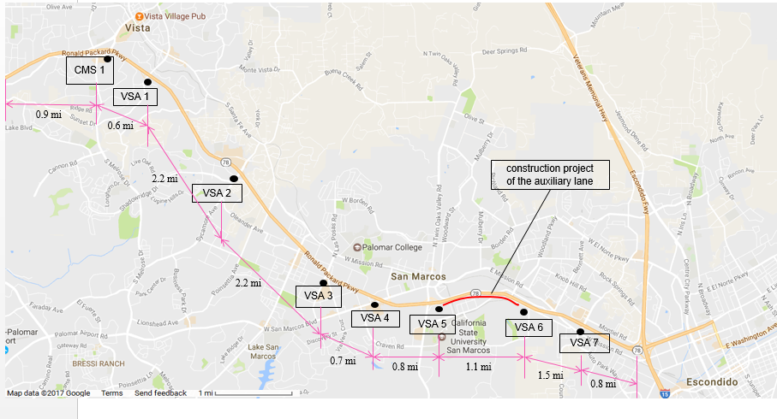

**Fig. 3:** Overview of VSA sign locations and the Construction Area

1. **Location Labeling on Google Map**

The hourly on-ramp flow data obtained from the PeMS system is listed Table 1 below, along with the corresponding postmile and traffic demands volumes of the are on-ramps. It can be observed that the highlighted on-ramps have relatively larger flow volumes onto the freeway mainline.

**Table 1**: List of EB SR78 Area On-ramp

|  |  |  |  |  |  |  |  |
| --- | --- | --- | --- | --- | --- | --- | --- |
| **City** | **PM** | **Abs PM** | **ID** | **Name** | **Lanes** | **HOV** | **Agg. Max demand**  **(veh/hr)** |
| Oceanside | 0.858 | 0.854 | 1108642 | JEFFERSON ST | 3 | No | 557 |
| Oceanside | 1.594 | 1.59 | 1108640 | EL CAMINO REAL | 2 | No | 2360 |
| Oceanside | 3.586 | 3.582 | 1108638 | PLAZA DR. (COLLEGE) | 2 | No | 871 |
| Oceanside | 4.474 | 4.47 | 1108329 | EMERALD DR. | 2 | No | 1112 |
| Vista | 6.32 | 6.316 | 1108650 | VISTA VILLAGE DR. | 3 | No | 1574 |
| Vista | 6.886 | 6.882 | 1108636 | SUNSET/ESCONDIDO | 2 | No | 1205 |
| Vista | 7.796 | 7.792 | 1108634 | MAR VISTA DR. | 2 | No | 442 |
| Vista | 9.218 | 9.214 | 1108646 | SYCAMORE AVE | 3 | No | 1109 |
| San Marcos | 10.68 | 10.676 | 1108550 | RANCHO SANTA FE RD | 2 | No | 868 |
| San Marcos | 11.364 | 11.36 | 1116450 | Las Posas Rd | 2 | No | 846 |
| San Marcos | 12.274 | 12.27 | 1108602 | SAN MARCOS BLVD | 3 | No | 1891 |
| San Marcos | 13.022 | 13.018 | 1113559 | TWIN OAKS VALLEY RD | 3 | No | 2786 |
| San Marcos | 14.86 | 14.856 | 1108703 | BARHAM DR. | 2 | No | 844 |
| San Marcos | R15.597 | 15.593 | 1108707 | NORDAHL RD | 2 | No | 1182 |
| Escondido | 16.739 | 16.739 | 110477 | EB ON FR I-15 | Missing | Missing | Missing |

With the above factors taken into consideration, the following VSA sign location are preliminarily proposed, which will be subjected to further consideration and revision. We have until early September to finalize these locations.

***CMS 1***: Vista Village Dr., in the city of Vista. The information displayed on this sign could be any of the following:

* Entering Variable Speed Advisory Test Area
* Speed Harmonization Field Test in Progress

***VSA Sign 1***: Sunset Dr., in the City of Vista

***VSA Sign 2***: Sycamore Ave, in the City of Vista

***VSA Sign 3***: Las Posas Rd, in the City of San Marcos

***VSA Sign 4***: San Marcos Blvd, in the City of San Marcos

***VSA Sign 5***: Twin Oaks Valley Rd, in the City of San Marcos

***VSA Sign 6***: Woodland Parkway, in the City of San Marcos: it is not an on-ramp, but needs a VSA sign due for two reasons: one is the distance factor, and second the road geometry, there is a curve at this location.

***VSA Sign 7***: Nordahl Rd., in the City of San Marcos: This is the Critical VSA. Its location may need to be adjusted at the beginning of the test period to make sure that drivers have adequate distance for adjusting their speed before reaching the bottleneck downstream.

The following figures (Fig. 4- Fig. 11) have labeled the Sign locations on the Google Map from the most upstream to downstream in the traffic moving direction.

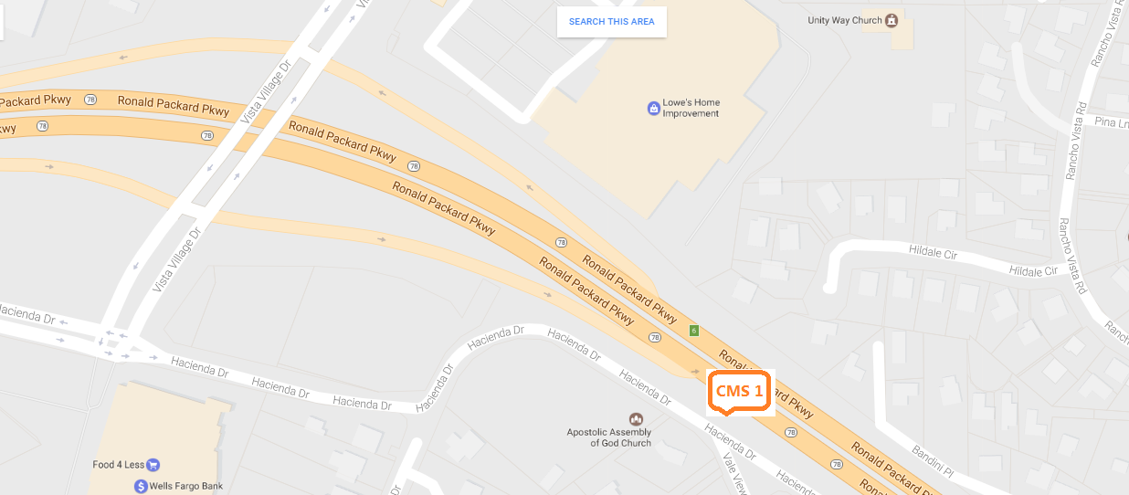

Fig. 4. CMS 1: Vista Village Dr., in the City of Vista

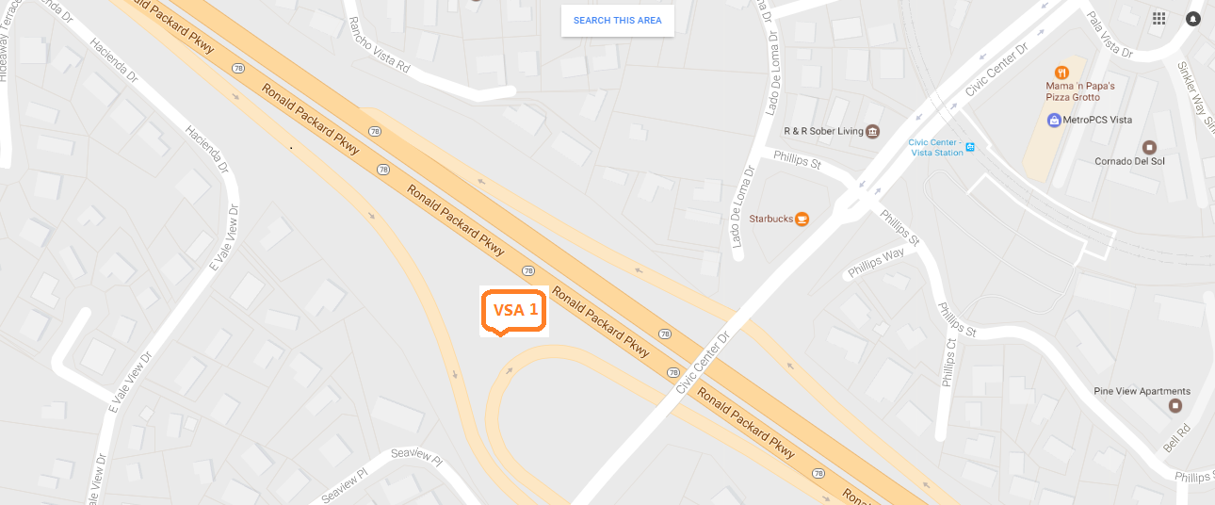

Fig. 5. VSA Sign 1: Sunset Dr., in the City of Vista

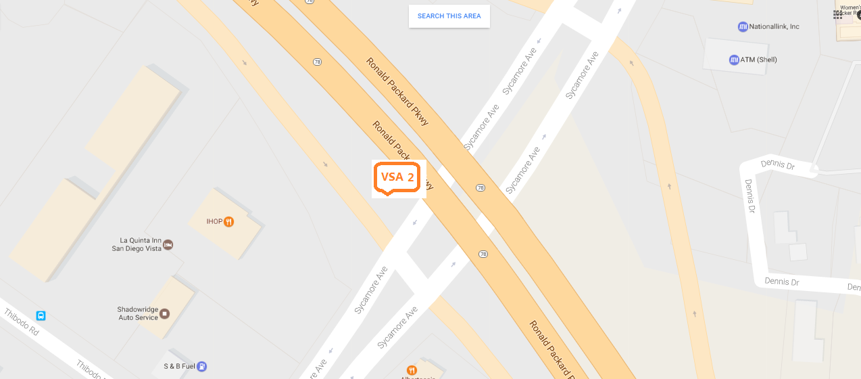

Fig. 6. VSA Sign 2: Sycamore Ave, in the City of Vista

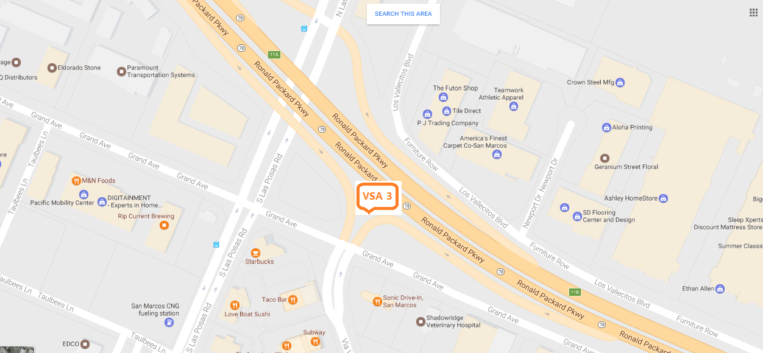

Fig. 7. VSA Sign 3: Las Posas Rd, in the City of San Marcos

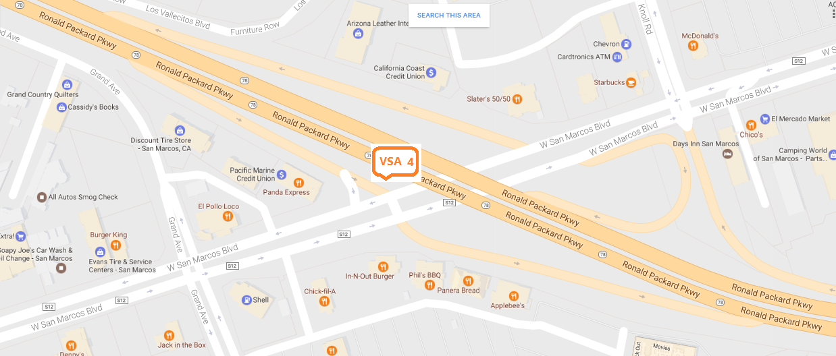

Fig. 8. VSA Sign 4: San Marcos Blvd, in the City of San Marcos

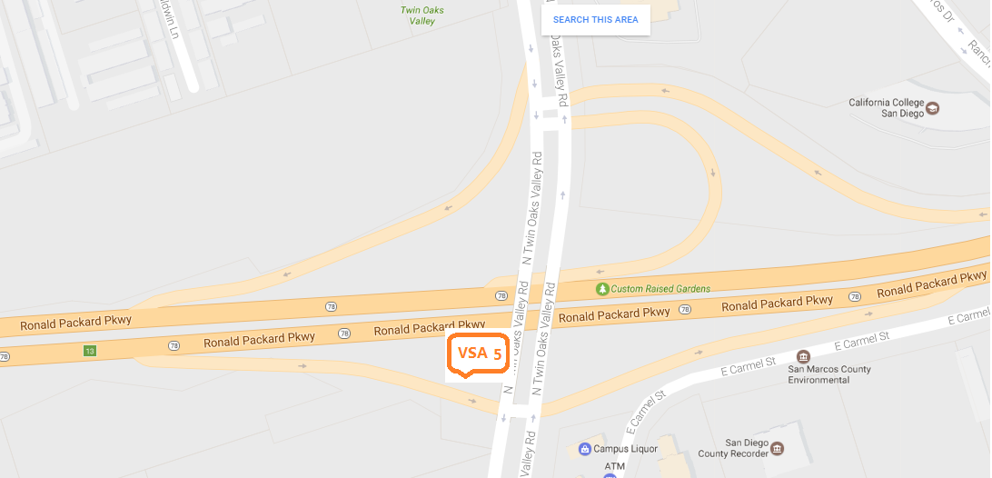

Fig. 9. VSA Sign 5: Twin Oaks Valley Rd, in the City of San Marcos

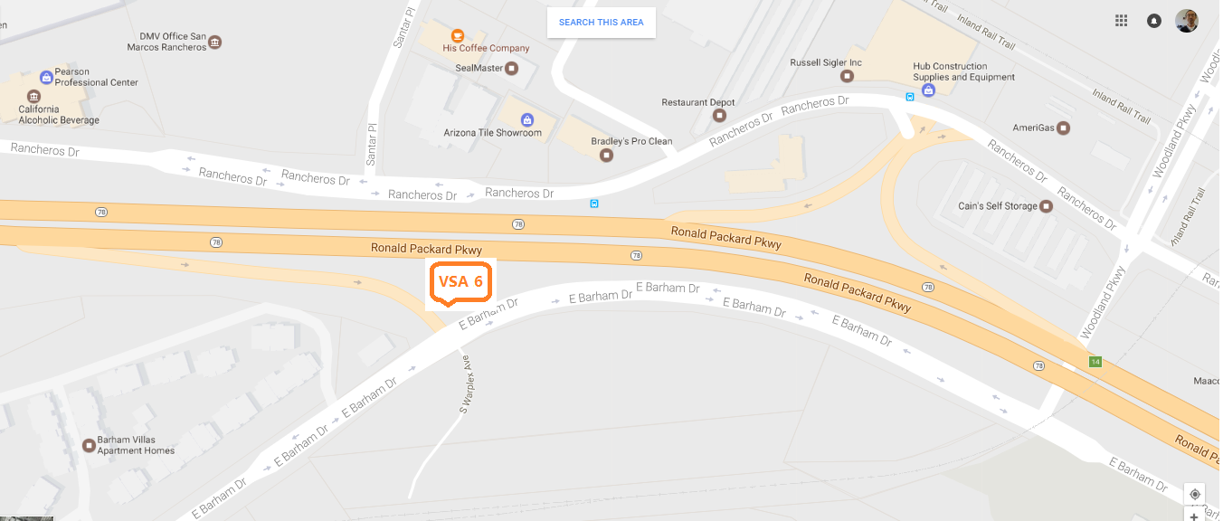

Fig. 10. VSA Sign 6: Woodland Parkway, in the City of San Marcos, not an on-ramp

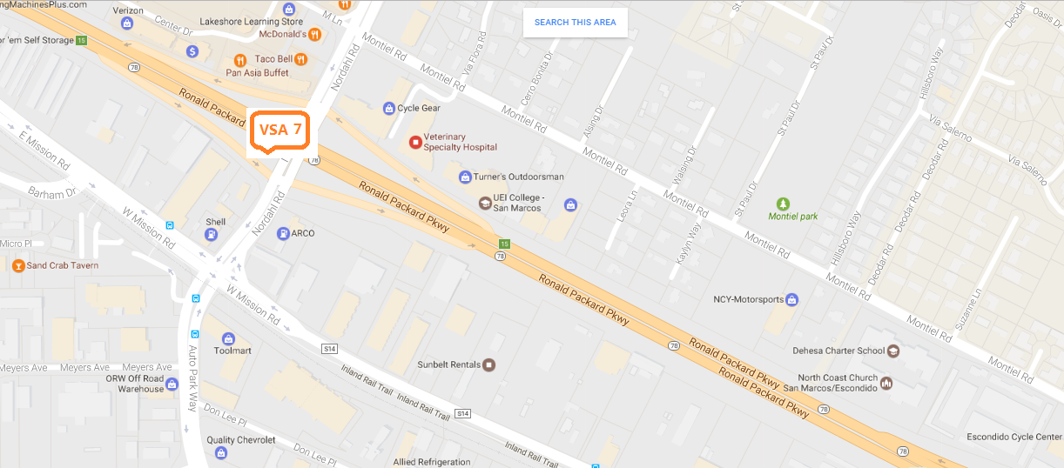

Fig. 11: VSA Sign 7: Nordahl Rd., in the City of San Marcos

Here is what a typical VSA sign may look like, with the speed value changeable remotely determined by the algorithms based on freeway traffic volumes and area congestion:

